## YUSUF MAITAMA SULE UNIVERSITY, KANO

## STUDENT INDUSTRIAL WORK EXPERIENCE REPORT CONDUCTED AT AUDU BAKO SECRETARIA, MINISTRY OF INFORMATION AND INTERNAL AFFAIRS, KANO.

## BY

## AMINU ABBAS IBRAHIM

## UG17ICT1042.

## A TECHNICAL REPORT SUBMITTED TO THE

## DEPARTMENT OF COMPUTER SCIENCE YUSUF MAITAMASULE UNIVERSITY, KANO

## SUPERVISED

## BY

## MALAM MURTALA MUHAMMAD

## AUGUST

## DECLARATION

I, Aminu Abbas Ibrahim with registration number UG/17/ICT/1042 hereby declare that I have written this technical report to the best of my knowledge.

**Aminu Abbas Ibrahim ------------**

**------------------- Date**

**(Student)**

## DEDICATION

I dedicate this work to the God Almighty, who against all odds, provided a place for my attachment and kept me safe and healthy throughout the period of my attachment.

## 

## ACKNOWLEDGEMENT

I want to acknowledge God for His provision and protection, thegeochemistry work team; for their support and sacrifices in order to makemy stay a success. I want to specially acknowledge the efforts of myparents; for their support andencouragement, deserves my invaluable gratitude, Finally, I want to appreciate my siblings and all myfriends who in one way or the other contributed to my success in this Industrial Training to you I say thank you.

## CHAPTER ONE

## ABOUT SIWES

## INTRODUCTION

Students Industrial Work Experience Scheme (SIWES) is one of the programs of the Industrial Training Fund (ITF), implemented to give the Nigerian students studying occupational related courses in higher institutions, the experience that will supplement their theoretical learning. It is designed to give students the needed practical experience in industries and other organizations so as to enable them contribute towards the industrial and technological departments of the country (ITF, ITF abuja portal, 2012).

The aim of this report is to give a detailed account of the student’s performance in the Industrial training and the experience gained during the time frame of his attachment, also to identify the problems encountered and possible solutions during the Period of attachment (ITF, ITF abuja portal, 2016).

## 1.2 HISTORY OF SIWES

SIWES was established by ITF in 1973 to solve the problem of lack of adequate practical skills preparatory for employment in industries by Nigerian graduates of tertiary institutions. The Scheme exposes students to industry based skills necessary for a smooth transition from the classroom to the world of work. It gives students of tertiary institutions the opportunity of being familiar and exposed to the experience needed in handling machinery and equipment which are usually not available in the educational institutions. Participation in Industrial Training is a well-known educational strategy (ITF, ITF abuja portal, 2012).

Successful internships foster an experiential learning process that not only promotes career preparation but provides opportunities for learners to develop skills necessary to become leaders in their chosen professions **(ITF, ITF abuja portal, 2012)**.

One of the primary goals of the SIWES is to help students integrate leadership development into the experiential learning process. Students are expected to learn and develop basic non-profit leadership skills through a mentoring relationship with innovative non-profit leaders. It is vital that each internship position description includes specific, written learning objectives to ensure leadership skill development is incorporated. Participation in SIWES has become a necessary pre-condition for the award of Diploma and Degree certificates in specific disciplines in most institutions of higher learning in the country, in accordance with the education policy of government. Operators - The ITF, the coordinating agencies (NUC, NCCE, NBTE), employers of labor and the institutions. Funding - The Federal Government of Nigeria Beneficiaries Undergraduate students of the following: Agriculture, Engineering, Technology, Environmental, Science, Education, Medical Science and Pure and Applied Sciences. Duration is four months for Polytechnics, Colleges of Education, and Six months for the Universities (ITF, ITF abuja portal, 2012).

## 1.3 AIM AND OBJECTIVES

## Aim of SIWES

SIWES is aimed at providing students with an opportunity to apply their theoretical knowledge in real work/life situations, thereby bridging the gap between theory and practice (ITF, ITF abuja portal, 2016).

## Objectives of SIWES

1. To serve as a platform were students from Nigerian tertiary institutions acquire industrial skills and experience in their fields.
2. To highlight to the students the working strategies and employment.
3. To expose students to method techniques and their respective institution.
4. To give an opportunity to employers’ involvement in the educational process or preparing graduates for employment industries.
5. To enable students to learn more on their field of study by interacting with experienced people in their respective fields.
6. To teach students the techniques and methods of working with facilities and equipment that may not be available within the walls of an educational institution.
7. To give students the ability to try and apply the given knowledge.**(ITF, ITF abuja portal, 2016)**.

## 1.4 VISION STATEMENT

To be the foremost skills training development organization in Nigeria, and one of the best in the world **(ITF, ITF abuja portal, 2016)**.

## 1.5 MISSION STATEMENT

To set and regulate standards, and offer direct training intervention in industrial and commercial skills training and development, using a corps of highly competent professional staff, modern techniques and technology **(ITF, ITF abuja portal, 2016).**

## 1.6 IMPORTANCE OF SIWES

1. SIWES provide students the opportunity to test their interest in a particular career before permanent commitments are made.
2. SIWES students will develop skills in the application of theory to practical work situations.
3. It also affords the students the opportunity of familiarizing and exposing themselves to the needed experience in handling equipment and machinery.
4. SIWES students will develop skills and techniques directly applicable to their careers.
5. It will increase a student's sense of responsibility **(Unimaid, 2018).**

## 1.7 APPLICATION AND POSTING

First, I received my SIWES letter from the SIWES coordinator. I filled all the necessary information on it and Center Audu Bako Secretariat, Ministry of Information and Internal Affairs, Kano as my place of attachment. I went to Audu Bako Secretariat, Ministry of Information and Internal Affairs, Kano and I identified myself with my school identity card and presented my SIWES letter.

The SIWES student’s supervisor at the center received the letter and signed, that is, proof that I have been accepted there, he took my details, which include: name, registration number, address and phone number. I returned the letter back to the school SIWES coordinator to be stamped, after which I made copies submitted to the departmental coordinator and the industry based supervisor.

I started attending the industrial training on the 29th of July, 2019 that is, immediately after the semester examinations late that month.

## 

## CHAPTER TWO

## ABOUT THE PLACE OF ATTACHEMENT.

Ministry of Information and Internal Affairs is the chief image-maker of Kano State Government. Its functions include: Liaising with all Federal Government Paramilitary Agencies; Collection, storage and publication of data on the State for the purposes of planning and records; Generation and monitoring of public response/reaction (feedback) through various media on government policies, programs and activities and gives an appropriate response; Coordinating the activities of Information Officers attached to Local Governments and MDAs in the State. The key services of the Ministry include: Public Enlightenment and Awareness; Sensitization and mobilization of members of the public on government programs and policies through production and airing of Radio, Television programs and IEC materials (Documentaries, Jingles, Mobile Cinema show, posters, stickers, banners, handbills, flyers, pamphlets, among others); Publication of official State Diaries, Calendars, Almanac Media Events (Press briefings/conferences, media tour); Publications of weekly newsletters, monthly magazines, speeches, periodical achievements and official reports; Production and distribution of official portrait of the state Governor, public events pictures and photographs; Production and sale of national flags and state emblem; Placement of official advertorials (condolences/congratulatory messages and public service announcements, rejoinders) in newspapers and magazines; Provision/hire of Public Address vans for public/private functions; Posting of Information Officers, Cameramen and Photographers to LGAs and MDAs; Registration of expatriate cultural organizations, processing of citizenship applications.

## THEIR SERVICES

We are committed to making a positive difference by providing the citizenry with accurate, reliable and timely information. In our quest to positively project the image and create awareness on Government policies and programs for sustainable development, we will:

* Provide accurate, reliable and timely information to the general public on government policies, programs and activities.
* Be non-discriminatory by providing equal opportunity for citizens to have access to public information in accordance with the Freedom of Information Act.
* Always be professional in the conduct/discharge of our duties as well as ethical in accordance with the public service rules and regulations.
* Offer honest and candid suggestions at any forum for the protection and promotion of the interest and development of the state as well as improvement of the welfare of its citizens.
* Ensure that our public enlightenment or awareness programs cover all user groups irrespective of gender, ethnicity or social status including the disadvantaged groups such as women, physically challenged and the illiterate.

## VISION

To be leading public information dissemination organ in Nigeria.

## MISSION

To vigorously pursue integrated harmonized and purpose-oriented management strategy that will facilitate free flow of accurate, factual and balanced information between government and the citizenry based on the principles of freedom of information, freedom of expression and freedom of press without prejudice to such issues as national security, individual rights to privacy as contained in the constitution and law of Kano State.

## CHAPTER THREE

## SIWES EXPERIENCE

## 3.1 INTRODUCTION

This chapter describes the practical knowledge and experience I acquired during the six months of my SIWES training in Audu Bako Secretariat, Ministry of Information and

Internal Affairs, Kano. During this period, I was able to acquire relatively much.

# 

## 3.2 EXPERIENCES& SKILLS ACQUIRED

* Project on Fiber Optics
* Computer Networking

## 3.3 PROJECT ON FIBER OPTICS

I participated in a project sponsored by the administration of the school YUMSUK, it is supposed to provide internet connectivity in the entire university’s new campus using optics fiber. We participated in the project because it was the responsibility of the Audu Bako Secretariat, Ministry of Information and Internal Affairs, Kano to oversee the project.

## 3.3.1 Fiber Description

Fiber optic cable is a silicon glass core that conducts data in form of light, rather than current as in coaxial cables and twisted pair wiring. The core is surrounded by cladding (glass) and then a plastic jacket. Fiber optic cables have the highest data carrying capacity of any wired medium. A typical fiber has a capacity of 50 terabits per second (50 x10­­12bits).

In fact, this data rate for years has been much higher than the speed at which standard electronics could load the fiber. This mismatch between fiber speed and nodal electronics speed has been called the “electronic bottleneck.” There are two major types of fiber: multi-mode and single mode.

The cable we used in this project is a 96 core cable which consists of 8 buffers with 12 cores each. Not all the cables were used in fact, not up to 1/3 of the core was used and all the rest were kept redundant.

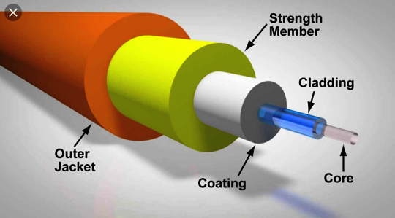

## Figure 3.1 Optics Fiber

## 3.3.2 Laying Fiber Optic Cable

I participated in laying fiber optic backbone cable, the holes were first dogged where the fiber is going to be laid, and the various hand holes (junctions). After that then the pipe was laid where the fiber is going to pass to each and every hand hole. The reason for building the hand hole is that we need to terminate the fiber that comes from two or more other pipes for the purpose of detecting any fault. And it is built according to the distance in meters between the individual cores. The cable is pulled using a rope to prevent physical harm.

We laid the cable first from the source, Audu Bako Secretariat, Ministry of Information and Internal Affairs, Kano hand hole, which was then passed from one hand hole to another.

## 3.3.3 Fiber Optic Splicing

Splicing is the process of joining the ends of two optical fibers together to establish a connection so that during transmission, there is minimal loss of light. We did the splice inside a rubber tool called fiber optic closure, which provides space and protection for the fiber optic cable splicing. There are two types of splicing; fusion splice and mechanical splice. But we used fusion splice while implementing the project.

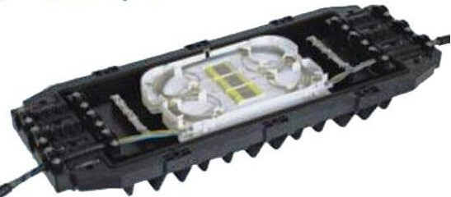

## Figure 3.2 Optic Closure

Fusion splice is when the ends of two fibers are fused together to become one single cable to become just as strong as the natural fiber. The place is covered by a heat-shrink plastic sleeve which protects the joint point.

First we added the protected heat-shrink sleeve to the fiber, we then used a stripper to peel out the bare fiber, we clean the fiber using a tissue which we pour chemical on it to remove all dirt. We then cleave the fiber using a cleaver which is a tool that holds the fiber and applies tension until the fiber breaks ,nothing is allowed to touch the cable for the purpose of good connection. We then used a fusion splicer to splice the two fibers together, the fusion splicer is an electric device that uses heat to join the ends of the two fibers together and ensure the two fibers are well cleaved. The last part of it is when the fibers become one, the fiber is then moved to the heat shrink sleeve to the particular place where the splice took place and place it under the area provided for heating the sleeve and the fibers together to ensure strong connections.

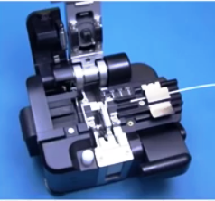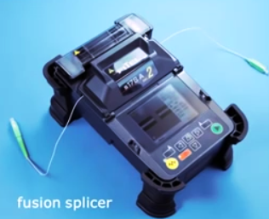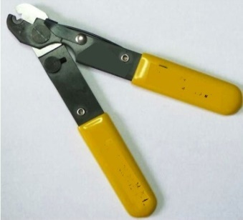

## Figure 3.3 Fusion Splicer and Cleaver

## 3.3.4 Fiber Optic Cable Termination

I participated interminating the fiber optic cable in a patch panel using a pigtail. Patch panel is a mounted hardware assembly that contains ports in which connectors are placed for the purpose of connecting and managing incoming and outgoing cables. A pigtail is an optic cable that is used to terminate an incoming fiber cable. We then installed a patch panel in a network rack for the purpose of connecting it to a switch, from the patch panel we then distributed the cables to a switch, a pigtail is connected to each port (patch panel) and the other end plugged into the switch port (one end fiber cable and the other end a pig tale).

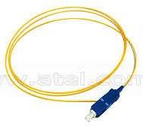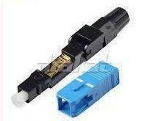

## Figure 3.4 Pigtail and Connector

The main purpose of a patch panel is to provide protection against external physical attacks for the cables, which contributes to ensure the cables performance in the whole network, because if one cable bend somewhere along the way where it will be difficult to locate, it will surely affect the network. Therefore patch panel helps in protecting the delicacy of the cables. It improves working efficiency and workflow because the technicians can connect or disconnect services to the actual locations simply by managing the patch panel.

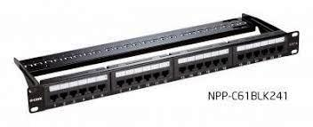

## Figure 3.5 Patch Panel

## 3.3.5 Optical Network Terminal (ONT) Router

An ONT router is a media gateway that converts optical signals to electrical signals, the router has both Ethernet and fiber optic ports. The ONT connects to the termination point (TP) with an optical fiber cable; it connects to the router via Ethernet cable and translates light signals from the fiber optic line in the TP into electronic signals that the router can read.

The configuration of the router is been done using the private IP address of the router that comes by default.

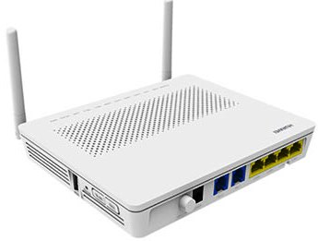

## Figure 3.6 ONT Router

## 3.3.6 Splitter and Face Plate

A splitter is a device that distributes the optical signal in an optical fiber transmission, due to its numerous input and output terminals. It is a very important passive device in an optical fiber link. Face plate on the other hand is an end component that is used to bring fiber to the desk. It transfers data or image pixel by pixel, fiber to fiber from one face of the plate to the other, in other words, it offers extension.

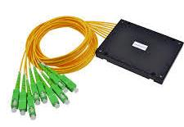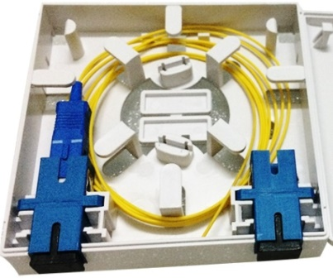

## Figure 3.7 Splitter and Face Plate

## 3.3.7 Installation of Router, Splitter and Face Plate

The installation of the router, splitter and face plate is been done in various departments where the network is needed and thus fiber is terminated there. A single fiber cable is taken from a hand hole and received in a patch panel through one of the several connectors on the patch panel. The received fiber is then connected to a pigtail on the other side of the connector (inside the patch panel). A splitter is then connected from the outer part of same connector (patch panel), the other eight pigtails of the splitter will then be connected to the remaining connectors of the patch panel for distribution to other destinations, one of which will be connected to the ONT router that is, the one that will provide the internet access.

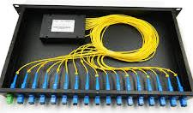

## Figure 3.8 Configured Panel.

## 3.4 COMPUTER NETWORKING

I was opportune to be part of a networking project at, Audu Bako Secretariat, Ministry of Information and Internal Affairs, Kano which was created for the purpose of educative programs, seminars, computer training and CBT examinations. It contains 250 computers which comprises of both desktops and laptops. These computers are assembled in order from 0-3 (servers) and 4 to 254 as clients, which we networked using star topology, we used switches and routers for the purpose of high speed signals and to detect faults easily.

## 3.4.1 Crimping of Cables

The Ethernet cable we used here is category 6 (cat6) because it transfer data over 100mbps, the cables are both shielded and unshielded. We crimped the cables both sides using either of the two types of arrangements that is, T568A and T568B.

T568A T568B

* White Green - White Orange.
* Green - Orange
* White Orange - White Green
* Blue - Blue
* White Blue - White Blue
* Orange - Green
* White Brown - White Brown
* Brown - Brown

We have two ways for connecting the cables, straight through and crossover.

* Straight Through – For connecting unlike networking devices. Examples are Router-Switch, Switch-Computer, and Router-Computer. The arrangement of the wires at both ends of the cable connector must be the same that is, either T568A or T568B.
* Cross Over – Used for connecting similar or like networking devices. Examples are Router-Router, Switch-Switch, Hub-Hub, and Computer-Computer. I also learnt that if one end of the cable is T568A then the other will be T568B.

The tools we used for crimping the cables are;

* Registered Jack (RJ) 45
* Crimper
* Stripers
* LAN Tester

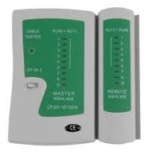

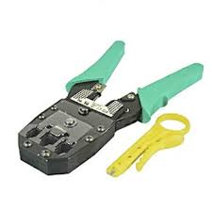

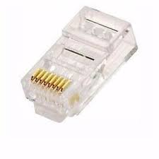

## Figure 3.9 RJ45, LAN Tester and Stripers

## 3.4.2 Assigning IP Address

We set all the IP addresses of the computers including the servers and the clients. The steps we used to assign the addresses are:

Step 1: Open network and sharing center

Step 2: Click change adapter settings

Step 3: Select Ethernet

Step 4: Select internet protocol version 4 (TCP/IPv4)

Step 5: Select set manually radio button

Step 6: Fill in the IP address, subnet mask, and the default gateway (IP address of the server)

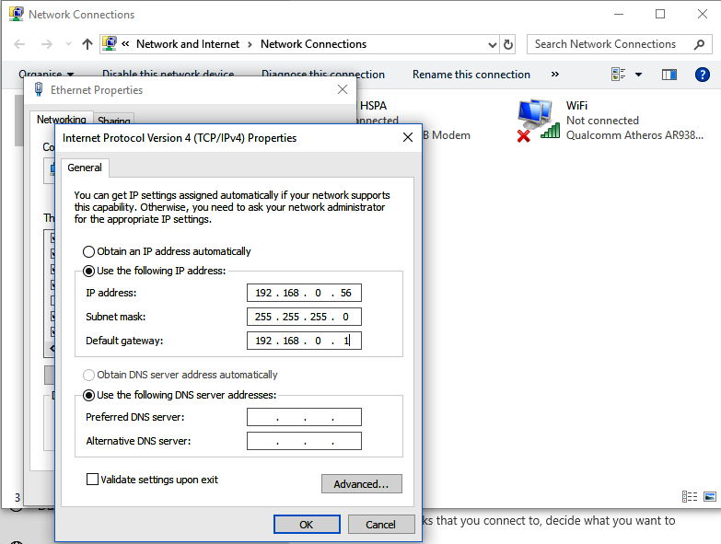

## Figure 3.10 IPv4 Properties

We also change the network of the whole computers to private network, so that they can share network devices and printers.

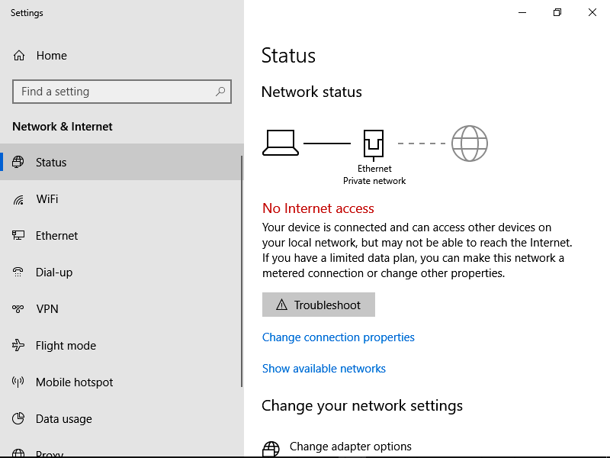

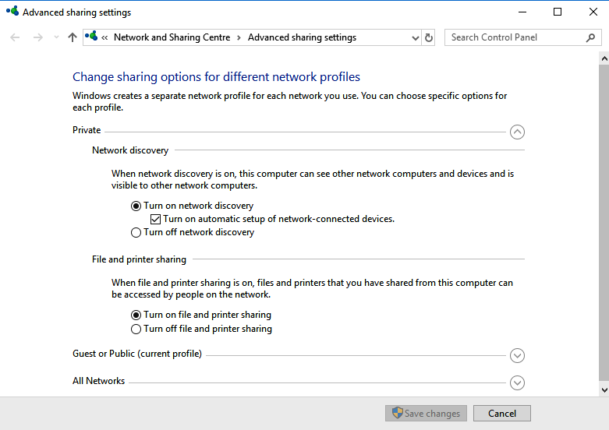

## Figure 3.11 Network Settings

## 3.4.3 Computer-Switch Connection

While trying to implement the project we chose star topology, because it does not allow complete network failure. The computers were grouped into 12, and each group has 22 computers and we used a 24 port switch for each of the groups leaving 2 redundant ports, we tested each and every computer and the switch to make sure they a seeing each other. A 24 ports backbone switch was used to connect all the switches, and then all the servers of the center were connected to the backbone switch, for easy accessibility of network and sharing of data.

## 3.4.5 System Administration

I learn some aspects of system administration, and that it is started by cleaning the disks that is, deleting all unnecessary applications, system optimization and making sure that the system is ready, efficient and is not infected by any malicious software, so that it can be used whenever needed without any fault. We also installed various applications in the system such as antivirus, and most the JAMB CBT applications for registration and document uploads. At last we numbered the computers from 1 to 250 for easy identification and debugging.

## CHAPTER FOUR

## SUMMARY, CONCLUSION AND RECOMMENDATION

## 4.1 INTRODUCTION

This chapter covers the overview of the report, the summary of the report, conclusion as well as the recommendations based on my experience gained through the SIWES program.

# 

## 4.2 SUMMARY

The Students’ Industrial Work Experience Scheme (SIWES) is a practical oriented scheme designed to improve scientific and technological skills and ideas to students in order to acquire the practical experience of the theoretical knowledge achieved in the lecture processes. This SIWES report is divided into four distinct chapters, the first chapter briefly talks about the introduction of SIWES, historical development of SIWES, Aims and objectives of SIWES. The second chapter gives the brief history of the place or industry of attachment. The next chapter talks about the SIWES experience, the practical knowledge acquired through the duration of the industrial exercise. And the last chapter is the summary, conclusion and recommendations.

The knowledge acquired as contained in this report is mainly of networking essentials; how to set up a simple network of connected computers in order to share resources; the physical methods of transmitting data (twisted pair cables and optics); a complete training course on the introduction of cyber security; and a lot of exposure and projects that we have participated in, in the vast site of the Federal University.

## 4.3 CONCLUSION

The importance of student industrial work experience scheme (SIWES) to both students and industries at large cannot be over emphasized. I think that the program is a great aid to students and it enhances learning and help in bridging the theoretical and practical gap as a result of much theoretical work in the school, especially to those of us that sincerely did the industrial training, not just to fill the academic demand but to get the required knowledge and skills in the field. I was not left out of this great opportunity that is provided by the SIWES program as mentioned in previous chapters, with this I say I have learned a great deal.

## 4.4 RECOMMENDATIONS

The following are some of the recommendations made, due to the experience gained at the course of the industrial training:

1. Students should be encouraged to choose a place of attachment whose activities are related to their fields of study, with a little guidance from the teachers.
2. There should be proper and strict supervision by the body (ITF) and various institutions concerned to ensure that the students acquire the required knowledge just as proposed by the scheme.
3. The institutions should ensure the regular supervisions of the students by the assigned supervisors (teachers).
4. There should be a strict attendance in the place or organizations of attachment to ensure the determination of the students.

## 

## REFERENCE

1. (2019). Retrieved from Hostinger Tutorials: http://www.hostinger.com
2. ITF. (2012). *ITF abuja portal*. Retrieved august 14, 2018, from http://www.itf.gov.ng/about-us.php
3. researchgate. (2016). *reseachgate*. Retrieved aug 14, 2018, from https://www.researchgate.net/publication/315028663_SIWES_TECHNICAL_REPORT/
4. Unimaid. (2018). *Student industrial work experience scheme 2018*. Retrieved aug 14, 2018, from http://www.unimaid.edu.ng/center/siwes.html